Dear Liaison,

Welcome and thank you for being the vital link between your school and The Youth Fair! We’ve made distributing information easier than ever before! Loaded on a convenient USB flash drive, you will be armed with all the tools you’ll need for a successful fair campaign with our Digital Toolkit! The toolkit will be pre-loaded with files that are ready for printing and distribution via email.

The DIGITAL TOOLKIT Includes:
- A letter from the Superintendent of Schools, Alberto M. Carvalho
- Handbooks
  - Student Exhibits & Youth Agriculture Exhibits Handbook
- Entry Forms
- Fair Maps
- Posters and Flyers
  - Important Dates & Field Trip Information
  - Timeline Calendar
  - Group Sales Information
  - Website Usage & Online Registration Information
  - Free Student Passes Information and Distribution Tips
- Awards and Scholarships
  - The Youth Fair Scholarship Program
  - Community Service Award- The Walter B. Arnold, Jr. Youth Hall of Fame
- Certificates
  - Certificate of Appreciation for Teachers

As a Liaison, you help The Youth Fair Showcase Youth Achievement and what better place than The Youth Fair? More than half a million fairgoers see the achievements of your school, teachers and students!

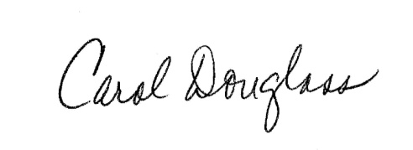
Sincerely,

Carol Douglass
Competitive Exhibits Director
Miami-Dade County Fair and Exposition, Inc.

