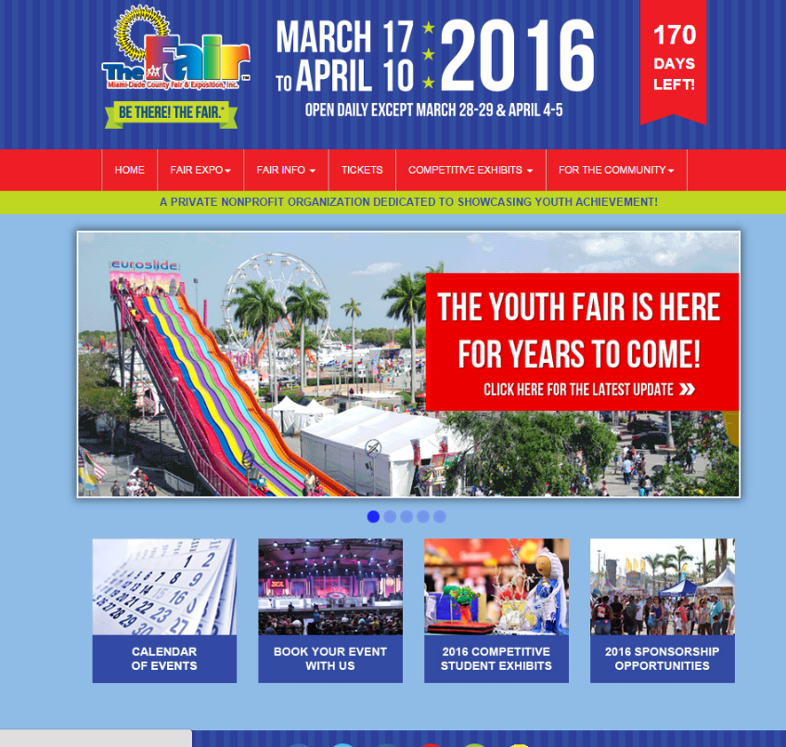
HOW TO VIEW OR PRINT THE STUDENT EXHIBITS HANDBOOK ONLINE:

In your browsers address bar type our URL: http://www.fairexpo.com/
You will arrive at our home page.

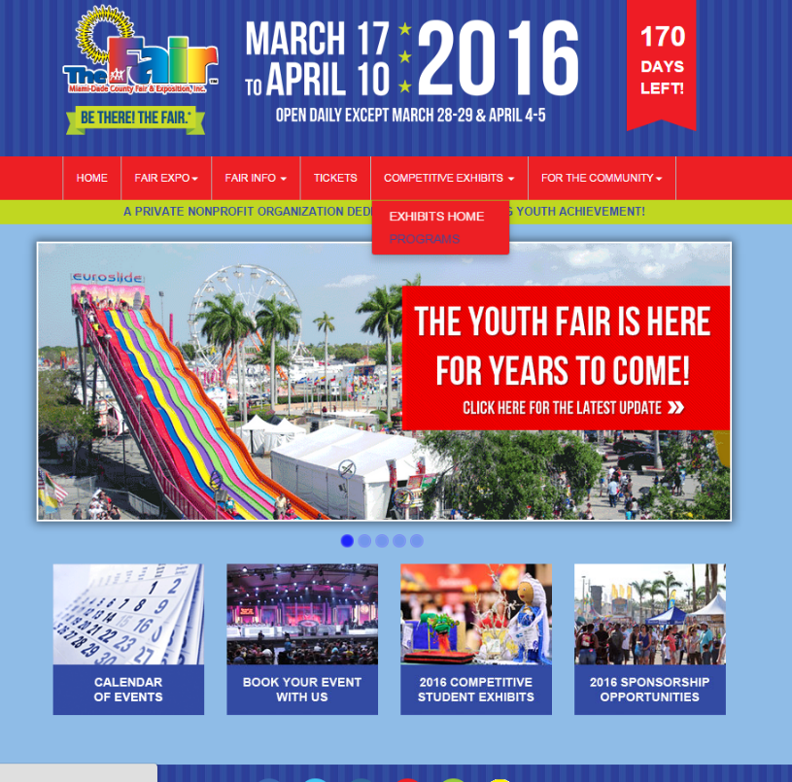
To view or print the handbooks, click on the “Exhibits” tab on the top navigation bar and then click on “Exhibits Home.”

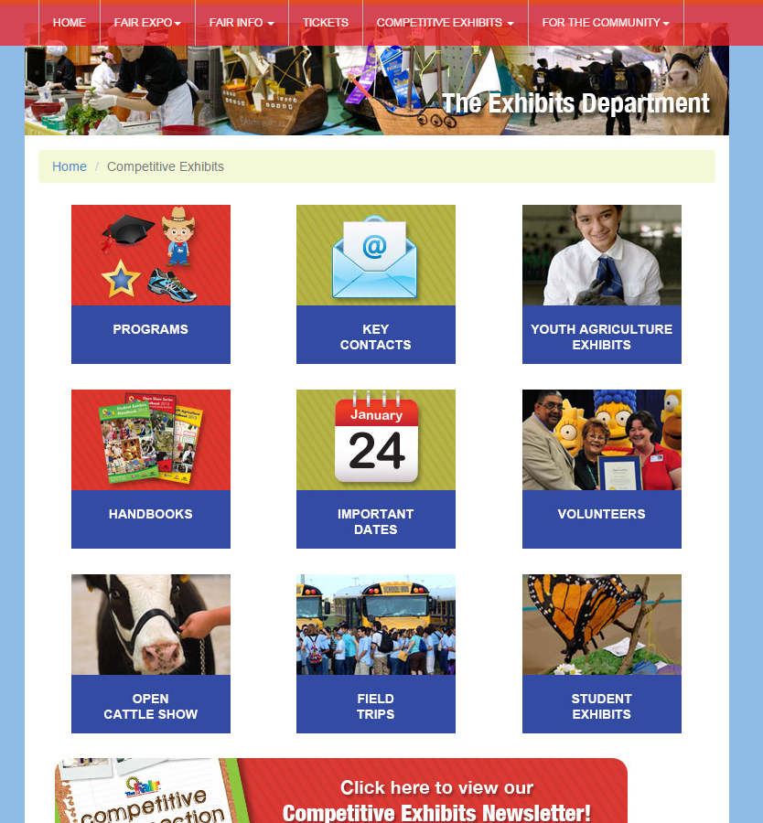
You are now on the Exhibits Homepage. Click on the “Handbooks” button or choose the category that best describes what you are looking for. A smaller page will pop-up and you can begin downloading or viewing the information immediately. You will need Adobe® Reader to view the files. Once opened, you can print the information.

If you have any questions, please feel free to email us at exhibits@fairexpo.com or call 305-223-7060 and ask for Student Exhibits.

